|  |
| --- |
| RD-Media Copyright 2011 |
| RD-Ticketmaster Mollie Plugin© |
| Joomla Version 1.0.14 – Mollie Ideal Version 1.0 |



|  |
| --- |
| Robert Dam – RD-Media  26-8-2011 |

**Documentation Index:**

This document has 4 chapters with the information how to configure the plugin for Rabobank I-Kassa.  
  
Documentation Index: 1  
Chapter 1: Configure the Plugin Part 1 2  
Chapter 2: Configure Mollie Environment 4  
Chapter 3 Configure the Message Center 5

*---  
  
Make sure you have configured all for a proper working of this plugin. We can never guarantee the working for 100%. So make sure you have made some test payments in your test environment. Also checking some payments and orders manually is needed!   
  
RD-Media will never be liable for loss of earnings by a not proper working of the component and or the plugin. You have to make sure you check the payments and your orders on a regularly base!*

***Extra Informatie (Dutch):*** *Mollie is een provider welke betalingen kan afhandelen. Het grote verschil met een Rabobank/ABN Amro of Ogone is dat Mollie minder data retour stuurt bij de return URL. Hierdoor kunnen we nooit exact bepalen om welke reden een betaling is afgewezen.   
  
Uiteraard stuurt Mollie wel data (naar een specifieke URL door ons gedefinieerd) welke verwerkt wordt in de database, hierbij wordt de betaling wel door ons gecontroleerd en de betstelling verwerkt. Indien bij Mollie vertraging heeft, dan kan het zijn dat het voor de klant lijkt dat er geen betaling gedaan is omdat Mollie in de korte periode geen bericht naar uw site heeft kunnen sturen.*

*Ze proberen meermalen een betaling te voltooien en zal dan als nog verwerkt worden. Bij het testen is dit nog niet voor gekomen en dus hebben wij alle betalingen en tickets gewoon kunnen afhandelen. Bij de terug komst van de klant wordt gecontroleerd of er wel of niet verzonden en betaald is.*   
  
---

**Chapter 1: Configure the Plugin Part 1.**Your plugin has been installed now, so you can configure it in a Joomla environment. Let’s take a look where to configure.  
Go to the Plugin manager:

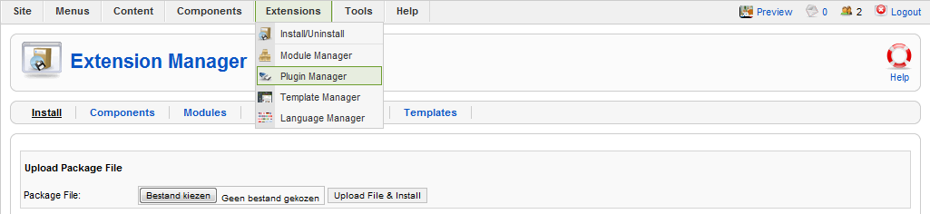

In the overview of your plugins, search for “RDMedia Mollie IDeal Plugin”.

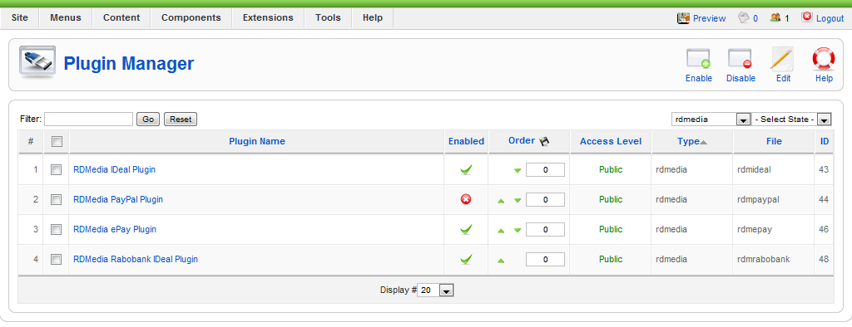

Open the plugin and you can configure it like you want.  
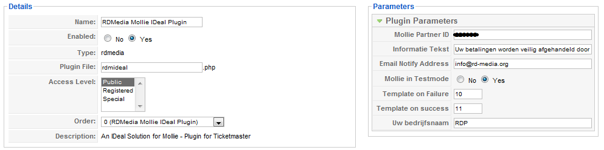

**Mollie partner ID:** See Chapter 2.

**Mollie in Testmode**: Are you running Mollie Ideal in test or production.

**Informatie Tekst**: Showing the message during checkout. (see screenshot with blue rectangle)

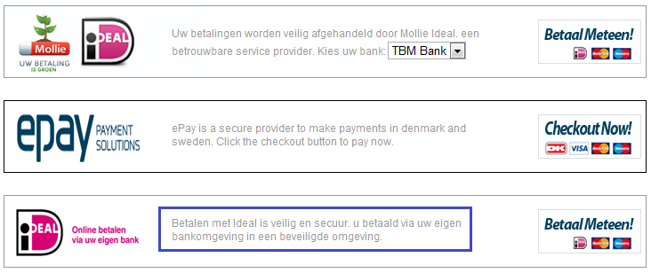

# The Templates for Mails and pages are described in Chapter 3.

# Chapter 2: Configure Mollie environment.

Logon to your mollie account at: <http://mollie.nl> And go to “Accountgegevens”

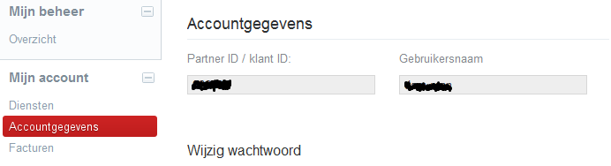

Please, copy and paste your Partner ID and set this one into the plugin at the Mollie partner ID.  
When you’re running Mollie in the test mode, then please take also the next step.  
Go to: <https://www.mollie.nl/beheer/betaaldiensten/instellingen/>  
  
Turn on the test mode. And you can receive money instantly.

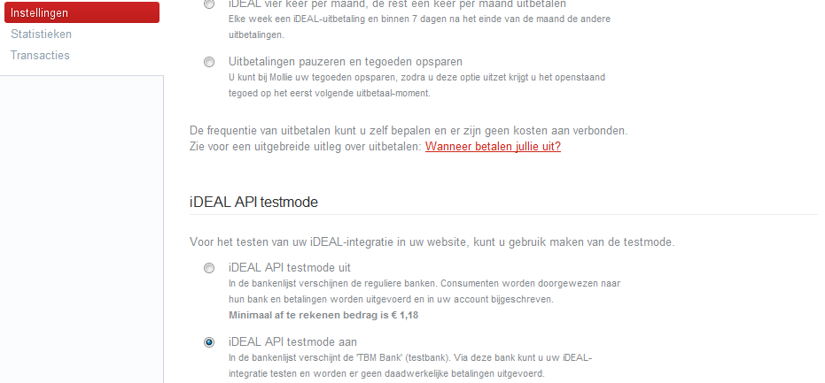

**Chapter 3: Configure the Message Center.**  
Now go to Ticketmaster in the components menu and then go to the message Center.  
We need to enter 3 messages. (Success message, Failure message and a Cancel message)  
*Don’t look to the Subjects as we’re using the same templates for all plugins in test environment)*

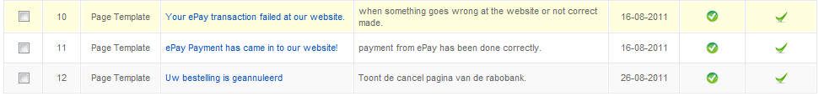

As you can see all templates has number in front it. We need those numbers for the templates. The success templates is also being used to send out and email to the client if you have enabled it. We do one example in the docs here:

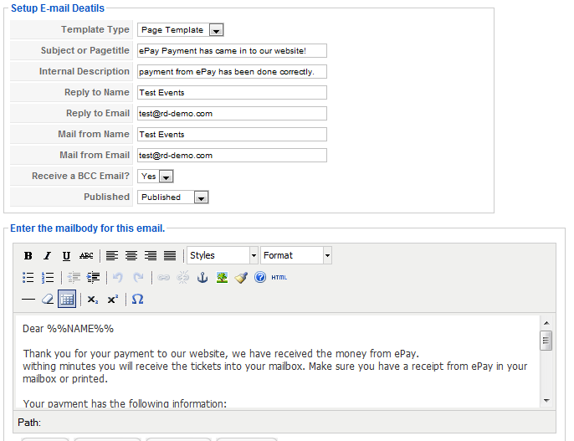

In this case the subject will be used for your email and for the page header.  
The other fields are pretty clear, and can be filled out by you if you want to send out emails. In the accept email you can use the following replacements:

* %%TID%% ( 🡪 Will be replaced with the transaction ID from Rabobank. )
* %%OID%% ( 🡪 Will be replaced with the orderid from our component )
* %%AMOUNT%% ( 🡪 Will be replaced with the amount of the order )
* %%DATE%% ( 🡪 Will be replaced with the date of the order )

For the declined pages and exception pages you can use %%MSG%% to show the error on your pages.  
We have entered 2 of the 3 templates below. The cancel message is just a message. No replacements!

Below you can find the template as we have it in our test environment:

**Success / Accept Email and Page:** *Dear %%NAME%%  
  
Thank you for your payment to our website, we have received the money from ePay.  
withing minutes you will receive the tickets into your mailbox. Make sure you have a receipt from ePay in your mailbox or printed.  
  
Your payment has the following information:*

* *Transaction ID: %%TID%%*
* *Order ID at our website: %%OID%%*
* *Paid Amount: € %%AMOUNT%%*
* *Payment Date: %%DATE%%*

*We have also sent an message to %%EMAIL%% with the above information.  
Thank you for your order with [WEBSITENAME]*

*Best regards,  
Sales team or your name.***Denied / Error Page:**

The Rabobank transaction failed for some reasons, please contact our sales department for further instructions.  
If you payment has been done and confirmed by Rabobank, please send a receipt with it.

We received the next message from Rabobank;  
**%%MSG%%**

Sorry for the inconveniences, we hope to see an email soon at: info@yourdomain.com  
Maybe you want to write some extra information about not doing more transactions from now on....

Best Regards,  
Webteam Website